BAGGAGE MANAGEMENT APP

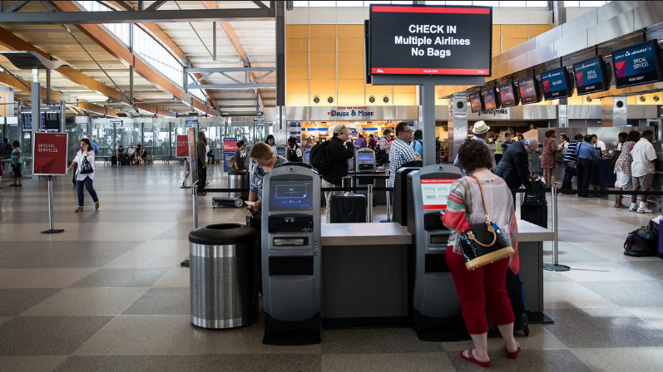

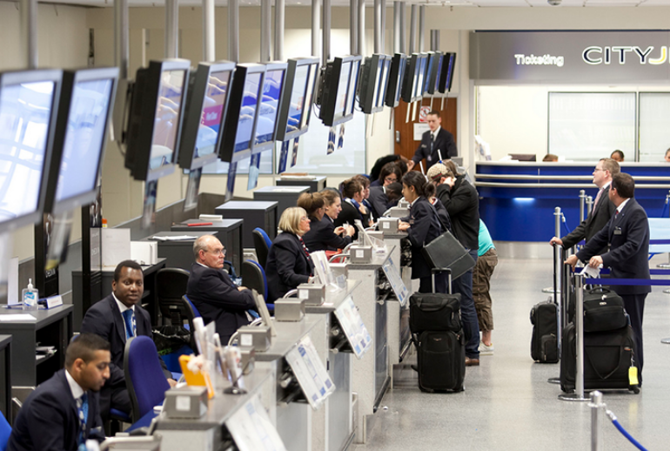

**Description:**

The project is a baggage check-in system which allows the user different features described below:

(The features are complete but their applications and uses could not be made in effect.)

- Passenger Check-in:

The details of the passenger are entered and stored in the database.

This feature can be enhanced so that the passenger can automatically check-in his bags.

- View Baggage in Transit:

At any given time, the user (airline management) can access the details of the bags in transit.

This feature helps determine baggage load at a given time and corresponding improvements can be made.

- Delivered Baggage:

Once the bag is delivered back to the customer, its status can be changed in the database. The management can track the recently delivered baggage.

This feature can help in tracking time taken for baggage in a certain flight to be delivered after it has landed.

- Missing Baggage:

All the unclaimed baggage is stored until the right customer comes to claim his lost bag.

**UML DIAGRAM**

|  |  |
| --- | --- |
| **Passenger** | **Baggage** |
| * FN : string * LN : string * PassportNo : string * Number_bags : int | - status : string  - barcode : long unsigned int  - weight : double |
| + Passenger();  + ~Passenger();  + void setFN(string) : setFN  + string getFN() : string  + void setLN(string) : void  + string getLN() : string  + setPassportNo(string) : void  + string getPassportNo() : string  + void setBags(int) : void  + int getBags() : int  +getPassengerInfo() : string  +saveDataToFile(Passenger) : void | +setweight(float) : void  + getweight() : float  +setStatus(string) : void  + getStatus() : string  +getbarcode() : long int  +getbarcode(bool) : long int  + setbarcode(string) : void  + checkweight(float) : void  + getBaggageInfo() : string |